The St. George’s Institute

Michaelmas Term
End of Term Assessment
2021


Subject: ELECTRONIC DOCUMENTATION PREPARATION & MANAGEMENT
Course: EDPM 201
Date: Monday November 29th, 2021 Time: 2:30 p.m. – 4:00 p.m.

Paper 1- Theory
1 hour

Instructions to Candidates
1. Answer ALL questions.
2. Number each answer correctly on your own file Paper.

Answer all questions.

1. (a) What is an operating-system program? ( 1mark )
(b) List THREE of the most common operating systems. ( 3 marks)
(c) Name TWO icons found on the Desktop of the Windows Operating System. ( 2 marks)
Total 6 marks

2. (a) State ONE purpose for which a scanner is used. ( 1mark )
(b) State ONE way to care for a keyboard. ( 1 mark)
Total 2 marks

3. (a) Three of the keys used for moving around within a document are given below. Give the abbreviation for EACH of these keys.

(i) Control keys
(ii) Page up
(iii) Page down ( 3marks)

(b) State ONE measure that can be used to protect the integrity of
computer files. ( 1 mark )

Total 4 marks

4. Copy Table 1 below on your own file paper and correct all errors and inconsistencies in style. Highlight your corrections by underlining them.
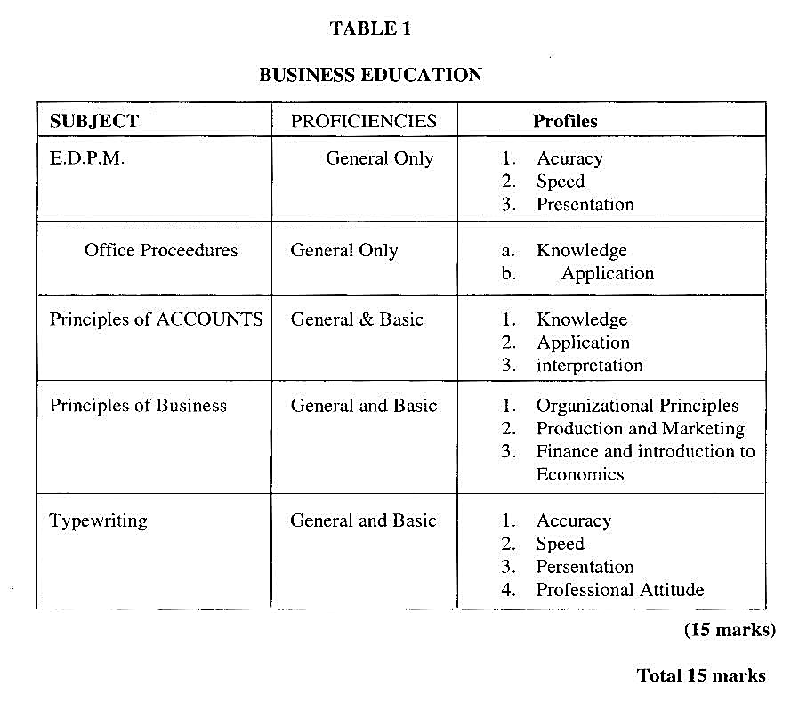

5. Copy Table 2 onto your file paper. Complete the table by stating the correct paper size and appropriate orientation that should be used for each of the three documents in the table.
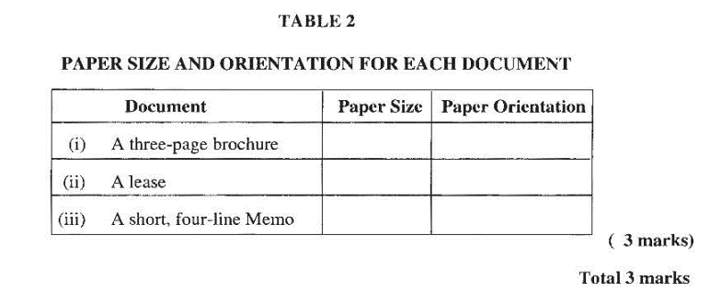
6. (a) Name TWO electronic communication media. ( 2 marks)
(b) State the function of a modem in a computer system. ( 1 mark )

Total 3 marks

7. (a) List FIVE steps used when creating an electronic document folder.
Total 5 marks

8. (a) List the sequence of operations for inserting ‘text boxes’ on a form.
( 3marks)

(b) Name TWO types of forms that may be created on the computer according to specific instructions. ( 2 marks)
Total 5 marks

9. Resa completed a research project, but she was penalized because the report contained words from another person’s work without acknowledgement of the author.

(a) Identify the term used for the act Elesa committed. (1 mark )
(b) State TWO methods that Elesa could use to acknowledge the author.
(2 marks)

Total 3 marks

10. Betty-Ann was given the following instructions by her boss:

“Please type this letter, but first confirm the date of the meeting with John Black by 10:00 a.m. I will be available for signature at 12:00 noon.”

Betty-Ann willingly complied in all respects.

(a) Identify TWO acceptable work standards Betty-Ann displayed. ( 2marks)

(b) Which TWO desirable habits and work attitudes did Betty-Ann demonstrate? ( 2 marks)

Total 4 marks

END OF TEST

