Kindly review the topic System programs and application programs posted on my core, then read and answer all the questions below.
Date: February 24th, 2022
Due Date: March 2nd, 2022
IT Level 1 – Homework
Name: __________________
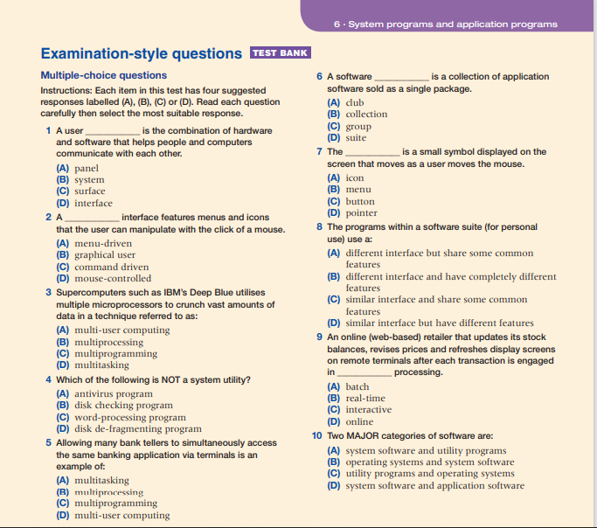
One (1) mark per question.

