EDPM Level 2
Invitation – Practice document
Instruction:
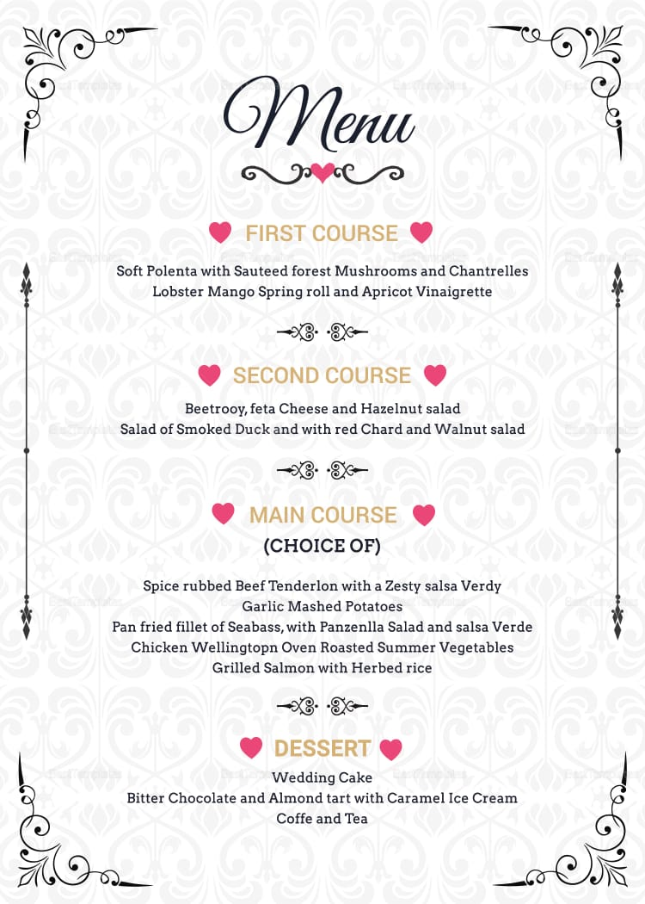
Create a 2-page booklet style invitation for your birthday party. Add the menu above to the invitation. Use appropriate formatting.

